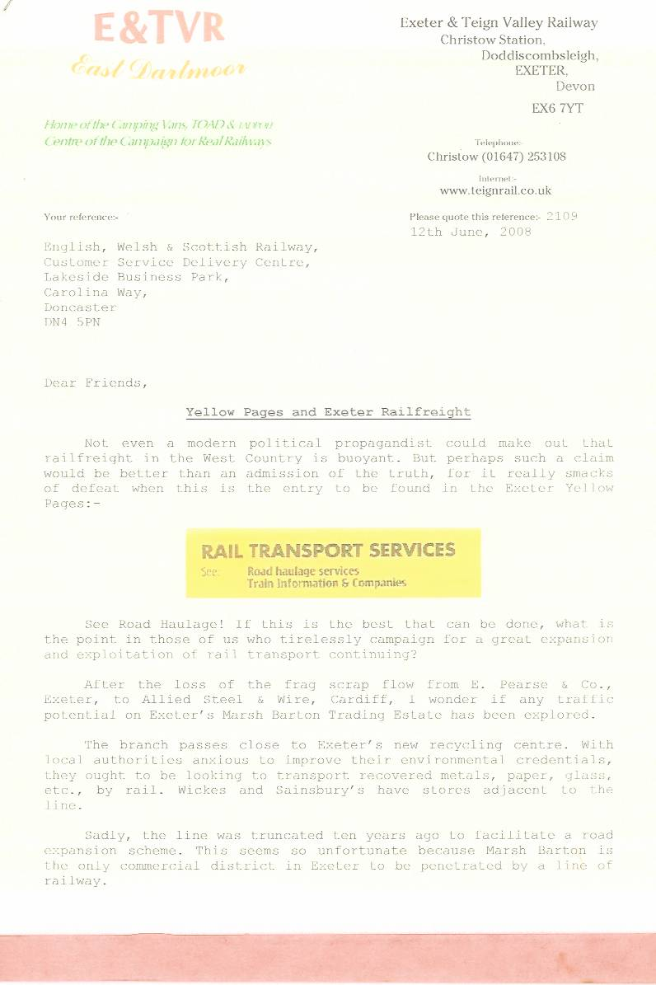

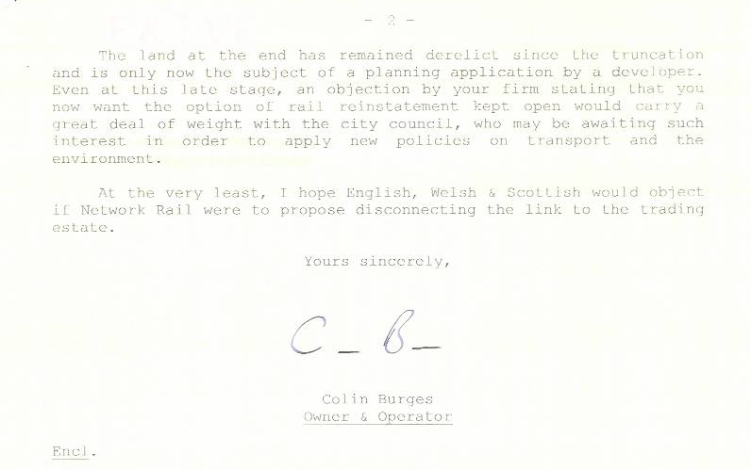
In response to a request for a piece to accompany a display which had been prepared for the 1997 Open Day, Julian Worth, English, Welsh & Scottish Railway’s General Manager, Business Devopment, kindly sent this refreshing statement outlining his company’s endeavours and intentions for the future.
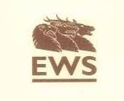

English Welsh & Scottish Railway (EWS) has set itself the target of doubling the amount of freight moving by rail in the UK by the middle of the next decade. It intends to do this by offering customers attractive services at competitive prices. In its first year of existence EWS has approved nearly £500m of investment in new locomotives and wagons—clear evidence of long term commitment to freight by rail in the UK.

To its established core business of trainload movement of bulk commodities and letter mail, EWS is now adding the Enterprise service for individual wagons and containers. Offering overnight transits between all regions of the UK for lorry-sized consignments. Using conventional wagons, containers and modern intermodal vehicles, Enterprise has grown from little more than 100,000 tonnes pa to over 1m tonnes pa in just over 2 years and is now moving goods such as food, drinks, freezers and light fittings as well as steel, chemicals and heavier products. June 1997 sees the introduction of a 75mph service between Scotland and England offering high speed rail based distribution for UK manufacturers and retailers.

